

Báo cáo Assignment

Lớp: WD18404 – HTML5

GVHD: Nguyễn Văn Long

SV: PS36816 Nguyễn Văn Quynh

**1:Trang Web- Figma**

+Figma: <https://www.figma.com/file/PbWJXOlvNImaDSBWvZKpvt/Shoppe-Clone?type=design&node-id=0%3A1&mode=design&t=cUMXYForiwyJwLeP-1>

**2. Sử dụng flex**

**3.LocalStorage**

**+** Thêm sản phẩm vào giỏ hang, lưu thông tin đăng kí đăng nhập.

**4.Sử dụng hiệu ứng css3**

+ Gradient: 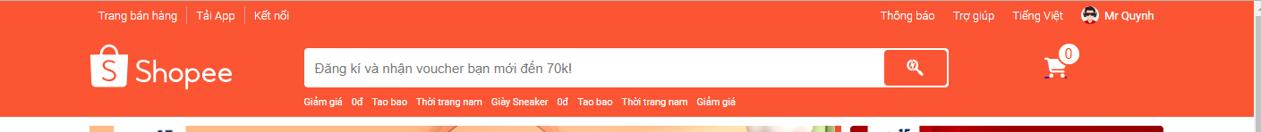

**5. Video**

